Abstract
Short abstract in Spanish - English - Italiano- Français- Português of no more than 200 words.

Keywords
Five keywords separated by semicolons.

Title
Name and Surnames (1); Name and Surnames (2); Name and Surnames (3) Name and Surnames (4); Name and Surnames (5)
- Department, University; (2) Department, University; (3) Department, University; (4) Department, University; (5) Department, University
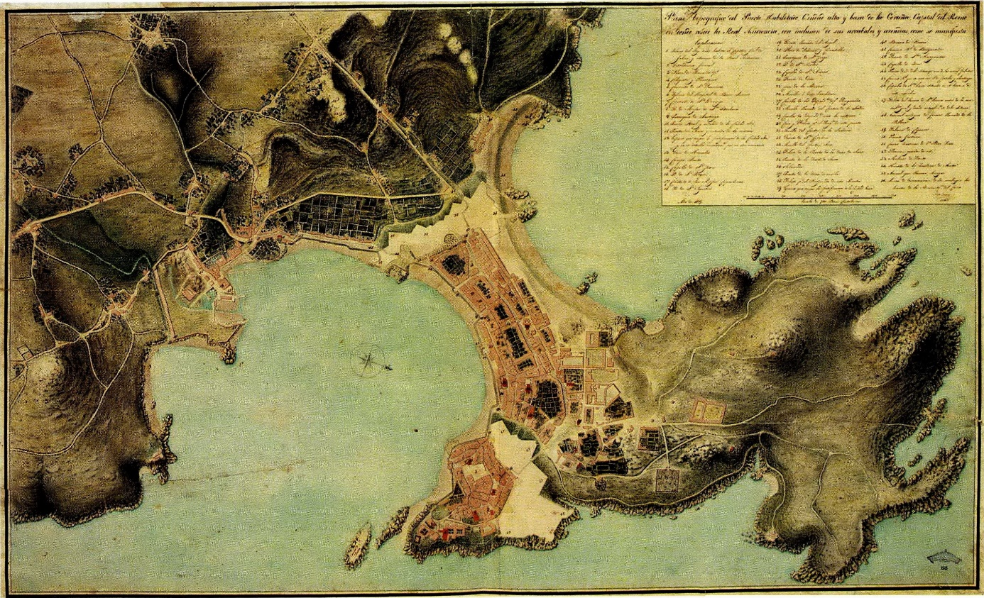
Figure 1. A representative image or a composite of several images (centred, maximum size: 14x10 cm).

- Introduction
Please use this document for the preparation of your short paper for the XIX International Conference EGA 2024. Authors should use this WORD document and the information contained in it as instructions for the structure and layout of the papers, making use of the template styles implicit in it.
Each paper must be adapted to this format, without modifying margins, column spacing, header and pagination.
Papers will be peer-reviewed by the Committee of Reviewers, considering the originality, innovation, structure, writing and content of the contributions. The paper must be an original contribution to the field of knowledge of architectural graphic expression and architecture, and must not have been published or submitted for publication elsewhere. An anti-plagiarism software will verify this prior to publication; any paper that does not observe this recommendation will be automatically rejected.
Papers will also be specifically required to be of an appropriate quality in terms of writing and syntax, as is appropriate for an academic text, and to be submitted within the deadline established for this purpose.
The introductory section will always begin in this column.

- Languages of the text
This short version of the paper will be part of a book of proceedings, which will be published in the author's native language. For this purpose, texts in English, Spanish, Italian, French and Portuguese will be accepted.

- Format
The short paper of your contribution to the congress will be limited to 5 pages. The last column of page five will be left blank so that, in the process of editing the proceedings, the sections corresponding to Biographical Data of the Authors and Acknowledgements, which will be requested from the authors with the final acceptance of the paper, can be entered there. These 5 pages are the space available to the authors to express and show the most important aspects of their contribution to the conference and the references on which it is based. It is therefore requested that each author adjusts, as far as possible, all the material to this length, respecting the format and not exceeding it in any case.
The document should be organised with a clear structure and content, in order to arrange and clarify the work, facilitating the review process and homogenising the contents of the publication.
It will consist of the following sections: Title; Abstract; Keywords; Short text; and References.
The title of the paper, heading the text, will be in EGA-title style [Adobe Garamond Pro 16, bold centred, 15-point exactly spacing and 6 point before and after paragraph spacing].
The sections structuring the document must conform to the corresponding styles of this template with the main points of the body of the paper numbered [styles EGA-normal, EGA-header, EGA-headernumber_1 and EGA-headernumber_2].

- Margins and design
The layout should respect the two columns, margins, justification and footer of this template; do not use footnotes, but integrate the necessary clarifications in the body of the text.

- Content, length and sections
  - Content and length
Papers should be concise and follow the structure of a research text. The text must be clearly structured according to the conventions of academic writing, and care must be taken in the writing and the choice of scientific vocabulary, typical of this type of document.
The maximum length of this short paper should be 1400 words, excluding the abstract, captions and bibliographical references.

  - Sections
- Abstract [maximum length 200 words] and keywords [five separated by semicolons].
They should clearly state the research items and approach in terms of theoretical contribution, results and main conclusions.
The text must adopt the EGA-abstracttext style [Adobe Garamond Pro 9, italics, 12-points exactly spacing].

- Short Text [maximum length 1400 words].
It must present the most important aspects of the research, with this structure:
Introduction and Background. Statement of the objectives of the work, based on the precedents that support the hypothesis of the research.
Discussion. Development and result of the research and scientific contribution contextualised in the field of Architectural Graphic Expression.
Conclusions. Achievements and contributions of the research.
The text must adopt the EGA-normal style [Adobe Garamond Pro 9.5, 12-points exactly spacing]. Graphs and tables will be inserted in their place.

- References.
List the bibliographical sources cited in the text in Harvard style. The text must adopt the EGA-normal style.

- Illustrations
Taking into account the theme of the conference, illustrations are considered to be of special interest in the development of the communication as support for the text or as an argument and guide for it. It is therefore encouraged to include a significant number of images in the papers and to take the utmost care with their quality.

  - Figures
Drawings, diagrams, photographs and digital images may be included; these will be referred to as figures. Figures will be inserted in the text, in which they will appear referenced (Fig. 1) and in simultaneous order, preferably at the beginning or end of a column.
Illustrations should be sent in colour and in a quality suitable for the print size. The resolution shall be 300 dpi for images and 600 dpi for line drawings, where special attention should be paid to their conversion to raster format.
It is important to adjust the figure to the width of one or two columns, taking into account its final orientation, and without leaving empty lines with the text or caption.
The caption, in EGA-figurecaption style [Adobe Garamond Pro 8, 12-point exact spacing], must contain the identification number and some basic data:
Figure 1. Work, Place, Year, (Source).
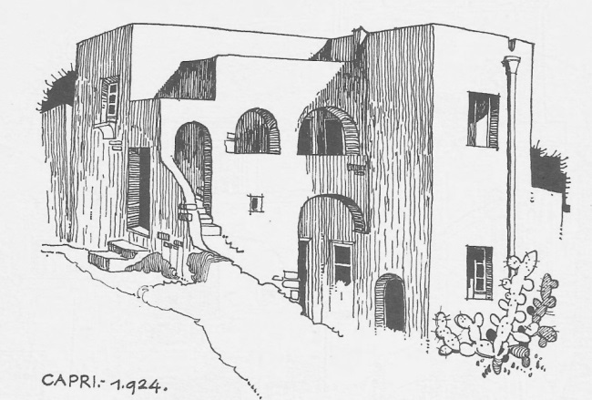
Figure 1. García Mercadal, F., A note on vernacular architecture, Capri, 1924 (García Mercadal 1996, 38).

  - Tables
Tables will be included in the text, after the paragraph where they are mentioned, in which they will be referenced (Table 1).
They will be simplified as much as possible, using only horizontal lines in their format and EGA-table style [Adobe Garamond Pro 8.5, 12-points exactly spacing]. No empty lines should be left with respect to the text or its title.
The title of the table must appear above the table in the same text style, EGA-table, as the contents of the table.

Table 1: Example of a simple table.
Number | Square
1 | 1,000
2 | 2,000

  - Copyright
As is traditional at EGA conference, the copyright of the texts corresponds to the authors and those of the edition of the proceedings to the institution that publishes it. Authors may, however, make digital copies for posting in institutional repositories and social research networks. Be sure to reference the sources of the images, if they are not self-produced.

- Citation style
Papers should include a compendium of references directly related to the work, which will support the content of the paper. The Harvard citation style will be used (https://n9.cl/4lz7b).
These references will mainly refer to books, scientific journals, conference papers and web resources.
Each reference must be shown in the text each time it is used and once in the final list of references, and there must be a correspondence between the citations in the text and the final list.
When references are cited in the text they must include:
- Surname of the author, editor or coordinator. Do not include proper names or initials.
- Year of publication.
- Page numbers, if applicable.
For example:
‘Many factors affect positive student outcomes (Johnston 2003, pp. 16-18)’.
‘Johnston (2003, pp. 16-18) says that there are many factors that affect positive student outcomes’.
When there are two or three authors of a reference, all their surnames are included in the text.
For example:
‘Según Cooper, Krever y Vann (2002) the use of this process leads to greater precision’.
If there are more than three authors in a reference, "et al." is used after the surname of the first author.
For example:
‘This has been suggested by Sandler et al. (2002) in their first Australian study’.
In the latter case, however, all authors are listed in the reference list in their correct order.

References
After the text, a section without reference numbering will be included. This is a single list of the books, scientific journals, conference papers and web resources cited in the text. This compendium includes the direct references on which the research summarised in this document is based. To ensure the scientific quality of the contributions, it is important that they are supported by a solid theoretical framework that consolidates them.
References should follow the alphabetical order of the authors' surnames. If several publications by the same author are cited, they will be ordered by date. Each of them will include all the details of its corresponding citation (author, date, title and editorial data), using the Harvard system, the basic structure of which is as follows:
Author, year. Title (in italics). Information about the publication.
Example of a book:
Author, date. Title (in italics). Place of publication: Publisher.
Daly, J., Speedy, S. y Jackson, D., 2004. Nursing leadership. Sydney: Elsevier.
Example of a paper journal:
Author, date. Title of the article. Name of the journal (in italics), number of the journal, pages of the paper.
Davis, L., Mohay, H. y Edwards, H., 2003. Mothers' involvement in caring for their premature infants: an historical overview. Journal of Advanced Nursing, n. 6, pp. 578-586.

Submitting your manuscript
For instructions on how to submit your paper, please follow the guidelines on the EGA2024 website.

[The last column will be left empty so that the sections corresponding to Biographical data of the Authors and Acknowledgements can be entered in the process of editing the proceedings.
This information will be required from the authors after the final acceptance of the paper and with the submission of the short version of the paper including all the data in WORD format].
Biographical data of the Authors
Name and Surnames (1)
Affiliation and email
Short CV: maximum 100 words. Including titles, professional career and teaching category, research group, line/s of research, etc.

Name and Surnames (2)
Affiliation and email
Short CV: maximum 100 words. Including titles, professional career and teaching category, research group, line/s of research, etc.

Name and Surnames (3)
Affiliation and email
Short CV: maximum 100 words. Including titles, professional career and teaching category, research group, line/s of research, etc.

Acknowledgements
To be added only if necessary.

